git help git => Open a website that shows help suggestions
staging area exist because you have 10 files which you have changed but you want to save only two files
git add <filename1> <filename2> .. <filename n> => to add multiple file to staging area.
git add . => to add all filed to staging area.
git commit -m “<commit message>”
git restore <filename> To restore the file when it is not staged
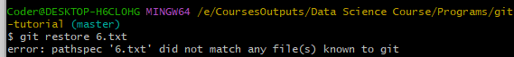
You will get above error if you try to restore untracked file that is not tracked in .git folder and it does not know about it.
To move from staged to unstage modified we execute
Git restore –staged <filename>
By this your file will be restored to its previous state it was in its previous commit
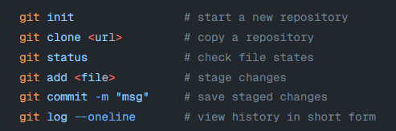

mkdir <folder name>
git clone <URL of repository to clone>
git echo "Hello Git!" > hello.txt => Adding a file
echo "This is my first change" >> hello.txt => Making Further Changes
git diff
Shows what you've changed but haven't staged yet.
It compared its unstaged version to its staged version if there is no staged version then last commit will be compared to unstaged version.
git diff –-staged
see what you changes you have done in staged area as compared to last commit
git diff HEAD~1 HEAD
Compare the last commit with the second last commit
Press Q to quit the infinite loop of showing result.
Press tab while typing command as it will auto correct.

